# **Portfolio task 4 - Statistics**

1. The heights of heather shrubs (*Calluna vulgaris*) were recorded and the data are presented in Column A in the Excel file ‘Statistical Data_Portfolio’.

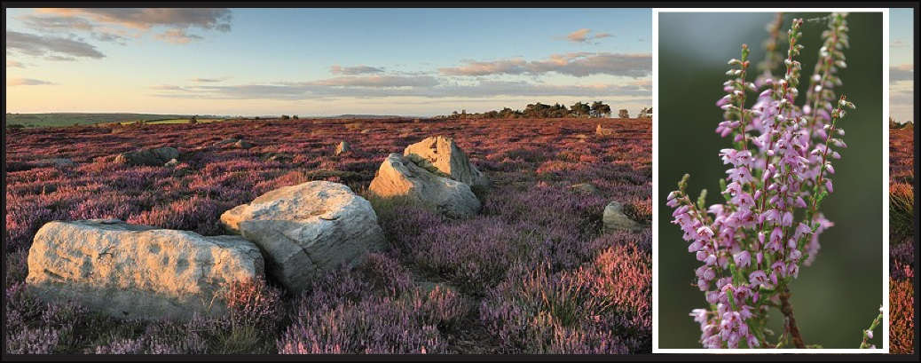

Heather moorland with an example of an individual plant in the inset

Plot a frequency histogram of the heather shrub height data. Are the data normally distributed (report skewness and kurtosis values)? Choose an appropriate measure of central tendency (either the mean, median or mode) and report the value (**2 marks**).

1. Two species of moths (Species A and B) have been collected in woodland and field habitats and the data are presented in Columns C-E in the Excel file ‘Statistical Data_Portfolio’. Use an appropriate statistical test to investigate whether there is any association between the habitat types and the two moth species recorded (**2 marks**).

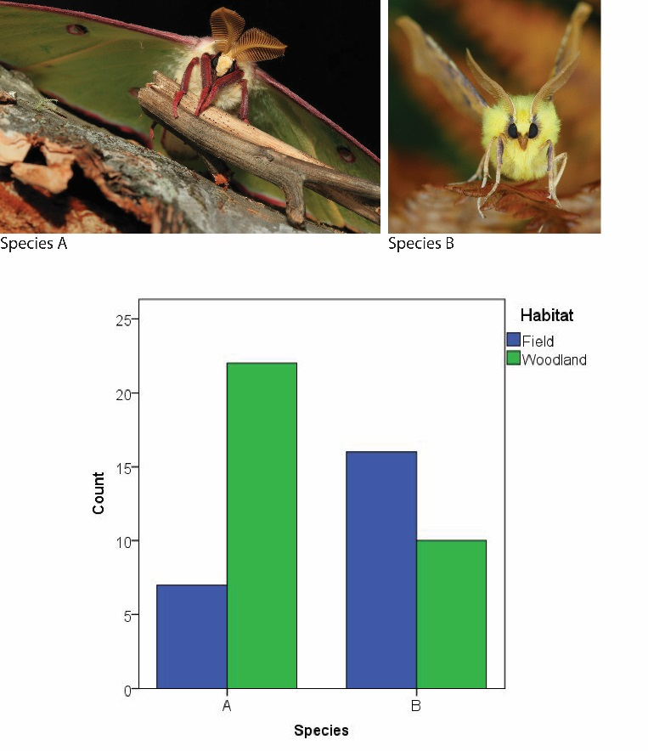

Counts of moth species A & B in woodland and field habitats

1. Assessments submitted by 9 students (anonymously labelled A-I) were double marked (the same piece of work for each student was independently marked by two academic members of staff (staff members X and Y). The assessments were assigned a mark on a 9 point *ordinal scale* which ranges from 0 (the lowest possible ‘score’) to 8 (the highest possible ‘score’). The data are presented in Columns G-I in the Excel file Statistical Data_Portfolio’.

Are the marks awarded by the two academic members of staff *consistent*?

In order to answer this question, you need to produce a scatter plot of the marks awarded and correlate the scores. For example, a high correlation between the scores awarded by the two staff members would suggest that the marks are a fair reflection of the work submitted. Choose an appropriate statistical test and report the correlation coefficient (**2 marks**).